Predictive Analytics and Business Strategy for Credit Card Fraud Detection
Introduction
Credit card fraud is a rare but high-impact problem for banks and card issuers: a tiny fraction of transactions are fraudulent, yet each undetected case can generate financial loss, damage customer trust, and harm the institution’s reputation. In real transaction streams, the data are extremely imbalanced. Under these conditions, simple rules or naive models that focus on overall accuracy are ineffective, because they can achieve very high accuracy while missing almost all fraudulent transactions. This makes fraud detection not just a technical challenge, but a business problem of identifying rare risky events without overwhelming operations and customers with false alarms.
Within this context, the project has three main objectives. First, it aims to build supervised predictive models that estimate the probability a transaction is fraudulent while explicitly accounting for the severe class imbalance. Second, it seeks to compare alternative models using metrics aligned with business priorities—especially recall and precision–recall behavior for the minority fraud class—rather than relying on raw accuracy. Third, it intends to translate these predictive results into actionable business insights, so that the model’s risk scores can support practical fraud management decisions such as setting alert thresholds, designing tiered intervention strategies, and balancing fraud loss reduction against customer experience.
Data and Methods
The data for this project is the transactions made by European cardholders in September 2013, which have been anonymized using Principal Component Analysis (PCA). The dataset has 28 PCA components (V1–V28), plus the variables Time (seconds since the first transaction) and Amount (transaction value in euros), and a binary Class label indicating fraud (1) or legitimate (0). For computational efficiency and to mimic the original fraud prevalence, a stratified random sample of 3,000 observations was drawn from the full dataset, preserving the real-world imbalance with 2,995 legitimate transactions and 5 frauds. Figure 1 visually confirms the extreme dominance of legitimate transactions on a log-scaled y-axis.
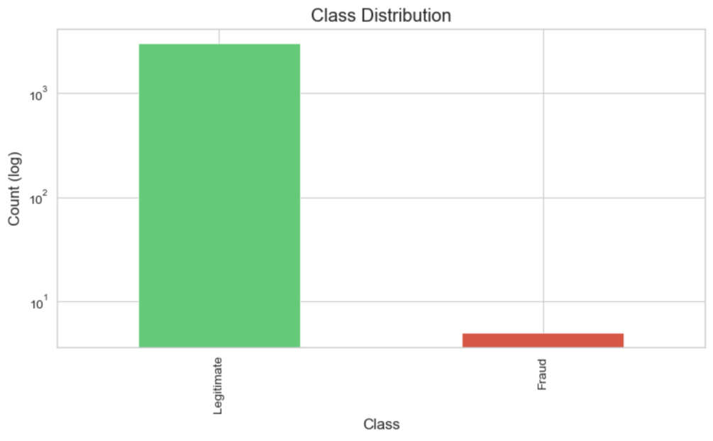
Figure 1. Class Distribution
In terms of predictive methods, the project focuses on two supervised learning models that are widely used in practice and well suited to highly imbalanced, binary classification problems. The first is a Logistic Regression classifier with class_weight="balanced". Logistic Regression is a simple, interpretable linear model that outputs calibrated probability scores, which can be directly mapped to risk levels and operational decisions. Using class weights allows the algorithm to penalize errors on the rare fraud class more heavily than errors on the abundant legitimate class, making it appropriate for rare-event detection. The second model is a Random Forest classifier with class_weight="balanced_subsample". Random Forest is a non-linear ensemble of decision trees capable of capturing complex interactions among the PCA components and the raw variables. It is included as a contrasting benchmark to test whether a more flexible, non-linear model can improve on the linear baseline in this extremely imbalanced setting. Both models produce continuous fraud probability scores for each transaction, which are evaluated and compared in the next section using metrics and visualizations tailored to rare-event classification.
Results and Discussion
Model performance is assessed with metrics that emphasize the minority fraud class. For each model, the area under the ROC curve (ROC_AUC) and the area under the precision–recall curve (PR_AUC) are computed on the test set, along with precision, recall, and F1 at the default threshold of 0.5 and at the threshold that maximizes F1. These results are summarized in Table 1 (Model Comparison). The class-weighted Logistic Regression model achieves a ROC_AUC of 0.9149 and a PR_AUC of 0.0192, far above the baseline precision implied by the fraud prevalence (~0.0017). At the default threshold of 0.5 it predicts all transactions as legitimate (precision = 0, recall = 0), which is typical in such imbalanced data. When the threshold is tuned to maximize F1, the best F1 occurs at a very low cutoff of about 0.0002, where the model reaches 100% recall with 1.92% precision.
Table 1. Model Comparison
 | Model | ROC_AUC | PR_AUC(AP) | P@0.5 | R@0.5 | F1@0.5 | BestF1_thr | P@BestF1 | R@BestF1 | F1@BestF1
0 | Logistic Regression | 0.9149 | 0.0192 | 0.0000 | 0.0000 | 0.0000 | 0.0002 | 0.0192 | 1.0000 | 0.0377
1 | Random Forest | 0.4841 | 0.0017 | 0.0000 | 0.0000 | 0.0000 | 0.0000 | 0.0017 | 1.0000 | 0.0033

By contrast, the Random Forest model performs poorly. Table 1 shows a ROC_AUC of 0.4841, slightly below 0.5, and a PR_AUC of about 0.0017, essentially equal to the baseline fraud rate. It also fails to detect any fraud at the 0.5 threshold, and even when the threshold is lowered to 0.0000 to maximize its F1, its precision remains extremely low and the F1 score is much worse than that of Logistic Regression. These numbers indicate that Random Forest does not meaningfully distinguish fraud from non-fraud in this setting, while Logistic Regression provides the only practically useful ranking of transactions.
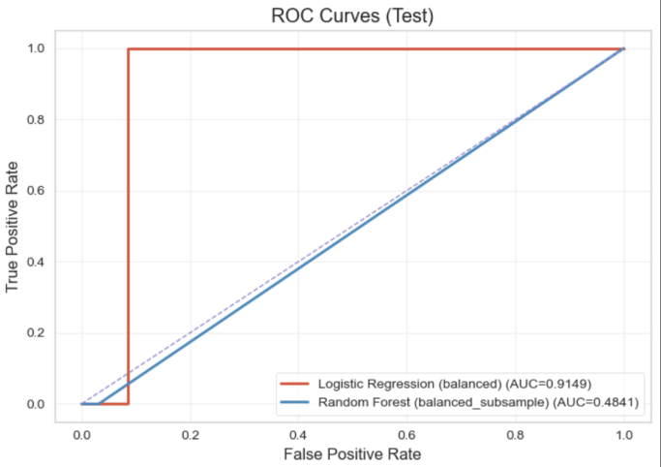
Figure 2. ROC Curves
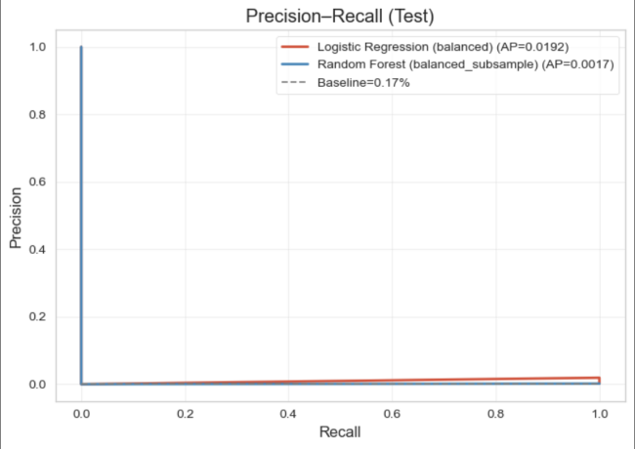
Figure 3. Precision-Recall Curve
The ROC curves in Figure 2 reinforce this conclusion. The Logistic Regression curve rises well above the diagonal “no-skill” line and occupies the upper-left region of the ROC space, consistent with its ROC_AUC of 0.9149 and indicating strong separation between fraudulent and legitimate transactions across thresholds. The Random Forest curve lies close to the diagonal, visually confirming that it behaves almost like random guessing. The precision–recall curves in Figure 3 are even more informative for this imbalanced problem. Logistic Regression’s curve sits clearly above the horizontal baseline at 0.17% and yields a PR_AUC of 0.0192, showing that it ranks the rare fraud case near the top of its list. The Random Forest curve hugs the baseline, with PR_AUC ≈ 0.0017, again showing little improvement over random selection.
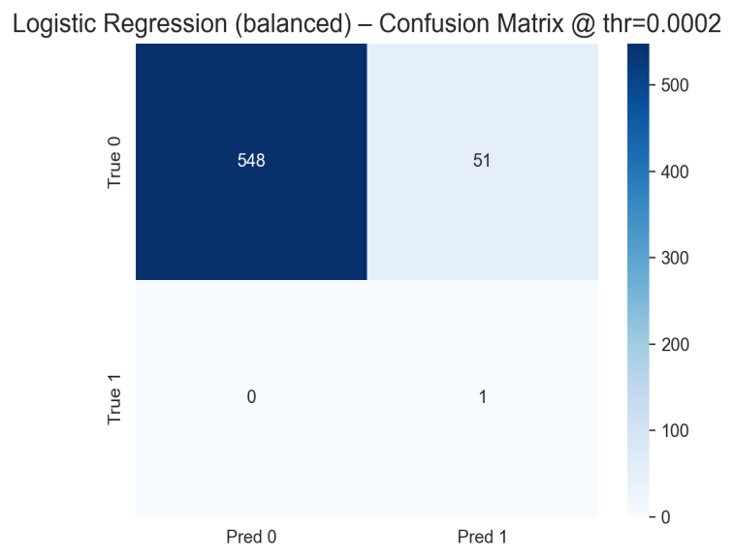
Figure 4. Confusion Matrix
Finally, Figure 4 shows the classification outcomes for Logistic Regression at its F1-optimal threshold of about 0.0002. On the test set, the model produces 548 true negatives, 51 false positives, 0 false negatives, and 1 true positive. Thus, recall for the fraud class is 1.00 (the only fraud is correctly flagged), while precision is approximately 1.92%, since only 1 of the 52 flagged transactions is actually fraudulent. This pattern captures the central trade-off of the project: eliminating missed fraud in this sample requires accepting a non-trivial number of false alarms. From a business viewpoint, these results suggest that Logistic Regression should be deployed as a risk-scoring engine rather than a strict yes/no filter, with its probability outputs mapped into multiple risk tiers and corresponding intervention strategies. In this way, the bank can exploit the model’s strong ranking ability (Table 1, Figures 2–4) while managing operational workload and customer experience more effectively.
Business Implications and Recommendations
The analysis has several important implications for how a financial institution could use the Logistic Regression model in practice. First, the model should not be deployed with the default threshold of 0.5, as this would result in zero recall and allow all fraud cases to pass undetected. Instead, the bank should adopt a much lower base threshold, such as the F1-optimal value around 0.0002, or a nearby value determined by internal cost–benefit analysis.
Second, rather than using a single decision rule at that threshold, the institution should adopt a risk-tiered strategy. Transactions with predicted probabilities far above the base threshold (0.000237) could be classified as high-risk and subjected to strong interventions, such as automatic blocking and immediate customer contact. Transactions with probabilities just above the threshold (0.000237) could be treated as medium-risk and verified using softer measures, such as one-time passwords, mobile app confirmations, or short-term holds pending customer response. Transactions below the threshold (0.000237) would be low-risk and processed without interruption, although they could still be monitored over time at the customer or account level. This multi-tier approach allows the bank to retain high recall for the most suspicious transactions while controlling the operational impact and customer friction associated with false positives.
Third, the model should be embedded within a framework of continuous monitoring and governance. Because fraud patterns change over time, model performance may deteriorate if it is not updated regularly. The bank should track key metrics such as PR AUC, recall on confirmed fraud cases, and false positive rates, as well as business measures such as fraud losses and customer complaint volumes. When these indicators signal a decline in performance, the model can be retrained on more recent data, thresholds can be adjusted, or new features can be engineered to capture emerging patterns.
Finally, the current model’s reliance on PCA components limits interpretability. For better business insight and regulatory transparency, the institution should invest in creating additional, more interpretable features based on transaction history, customer behavior, merchant category, geography, and device information. These features could improve predictive performance and help fraud analysts understand why certain transactions are flagged, making it easier to refine policies and communicate decisions to customers and regulators.
Conclusion
This project examined credit card fraud detection as an extreme imbalanced classification problem and developed a predictive solution that is both technically sound and business-relevant. Using a stratified sample of 3,000 transactions with only 5 labeled frauds, the study showed that a class-weighted Logistic Regression model clearly outperforms a class-weighted Random Forest benchmark. Logistic Regression achieved a ROC_AUC of 0.9149 and a PR_AUC of 0.0192, well above the baseline implied by the very low fraud rate. When the decision threshold was tuned to maximize the F1 score, the model reached 100% recall on the test set at a very low probability cutoff, effectively eliminating missed fraud in this sample but producing a non-trivial number of false positives.
These results underline a core reality of fraud detection: performance cannot be judged by accuracy alone, and any operating point reflects a trade-off between missed fraud (false negatives) and false alarms (false positives). At the F1-optimal threshold, the Logistic Regression model meets the project’s primary goal of not missing fraud but would generate many alerts if deployed directly at scale. This supports using the model as a risk-scoring engine rather than a hard yes/no classifier, with predicted probabilities feeding into tiered interventions—strong actions for high-risk transactions, softer verification for medium-risk ones, and unobtrusive monitoring for low-risk activity. In this way, the bank can leverage the model’s strong ranking ability while balancing fraud loss reduction, operational workload, and customer experience.
Looking ahead, there are several important directions for future research and business practice. One is to move from purely statistical thresholds to cost-sensitive optimization, explicitly incorporating the financial loss of undetected fraud, the cost of manual review, and the cost of customer friction into threshold selection and model evaluation. A second is to make the system more adaptive and granular, for example by using segment-specific thresholds (by customer value, channel, or region) and by combining supervised models like Logistic Regression with anomaly detection methods that can highlight emerging fraud patterns. A third direction is to invest in richer and more interpretable features and in continuous feedback loops: integrating behavioral, temporal, and device-based variables, monitoring model performance over time, and using confirmed fraud and false-positive outcomes to refine both the model and the surrounding business rules. Taken together, these steps can turn the current Logistic Regression solution into the foundation of a more powerful, adaptive, and business-optimized fraud detection system.

